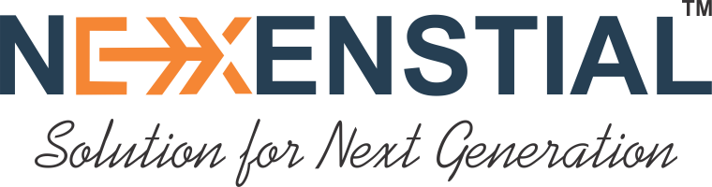

We Nexenstial kickstarted our journey in early 2022 currently situated at Dharwad Karnataka. We are proud to have been providing software development & IT Consulting to provide customer satisfaction using Leadership, Values & Long Term Relationships

We provide end-to-end innovative solutions to the customers & we have been a steadfast company focusing on the progress of our clients & developing relationships with our customers, partners & employees.

We are a seasoned organization providing top-notch services without compromise in customer business satisfaction. We are a one-stop solution for our clients for their diverse needs and level their global footprints that are able to help us overcome business challenges with a trustworthy, transparent approach & strong domain expertise.